**Frito Lay Safety Stock Dashboards**



Detailed Design Document

Contents

1. Introduction 3

2. Safety Stock – Location Level Dashboard 4

2.1 Landing Page 4

2.1.1 Filter Panel 4

2.1.2 Country/Regional Summary 6

2.1.3 Geographic Overview 7

2.1.4 Regional Overview 7

2.1.5 Location Summary for a Region 8

2.2 Location Deep-dive 8

2.2.1 Universal Controls/ Filters 8

2.2.2 Metric level Dashboards 11

3 Safety Stock - SKU Level Dashboard 18

3.1 Global Filters and Navigation 18

3.1.1 Home Navigation 18

3.1.2 Fill Rate by Product Navigation 18

3.1.3 Filters 19

3.2 Summary Points 21

3.3 Week on Week Comparison Table 22

# 1. Introduction

This document is prepared to elaborate the design specifications for the dashboards built as part of Safety Stock Visualization Project for US & Canada region. The dashboards are built in Tableau and are governed by design principles and best practices for visualization. The document is intended to be used as a manual for both end-users and support team alike in providing answers to some key questions that could arise when using the dashboard. The sections are grouped using a Top – Down approach, starting with the universal controls and parameters that govern the whole design, trickling down to specifics of each component per dashboard.

# 2. Safety Stock – Location Level Dashboard

This section outlines the overall controls and filters common across all dashboards in the Safety Stock Location Level Dashboard.

2.1 Landing Page

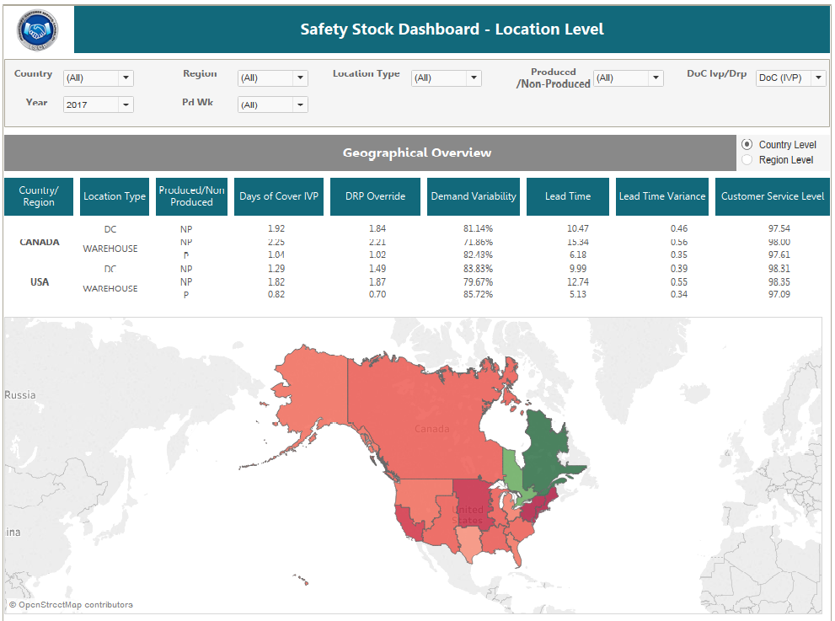

### 2.1.1 Filter Panel

The filter panel contains all the global filters that can be applied on all the dashboards



#### 2.1.1.1 Geographical Filters

Filters under this category correspond to the Geographical hierarchy and allow the user to make selection regarding the same.

#### 2.1.1.1.1 Country

This Filter provides the option to select a Country to view the data for the same

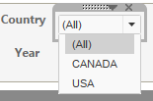

**Click here to select a Country**

#### 2.1.1.1.2 Region

This Filter provides the option to select a Region to view the data for the same.

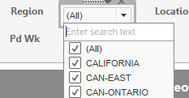

**Click here to select a Region**

#### 2.1.1.2 Location Type

This Filter provides the option to select a Location Type to view the data for the same.

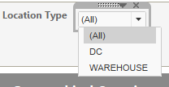

**Click here to select a Location Type**

#### 2.1.1.3 Produced/Non-Produced

This Filter provides the option to select Produced or Non Produced to view the data for the same.

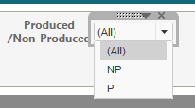

**Click here to select Produced or Non-Produced**

#### 2.1.1.4 Days of Cover Toggle

This filter provides the option toggle between DoC IVP and DoC DRP

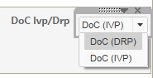

**Click here to toggle between DoC IVP and DoC DRP**

#### 2.1.1.6 Time Attributes Filters

Filters under this category correspond to the time hierarchy and allow the user to make selection regarding the same.

#### 2.1.1.6.1 Year Filter

The Year filter provides an option to select the year to view the data for the same.

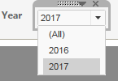

**Click here to select the Year.**

#### 2.1.1.6.2 Period Week Filter

The period here is divided into 13 periods according to the PepsiCo System, with each period having 4 weeks and the user can select one of the period-week combination for the selected year to view the data.

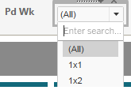

**Click here and select the corresponding period-week for which you want to view the data.**

### 2.1.2 Country/Region Summary

This gives a summary of all the metrics in the Safety Stock Location Dashboard at a Country and Regional Level. A Toggle between the Country Level and Regional Summary is present to help the user switch between the two views. Global filters can be used to filter the data in this view.

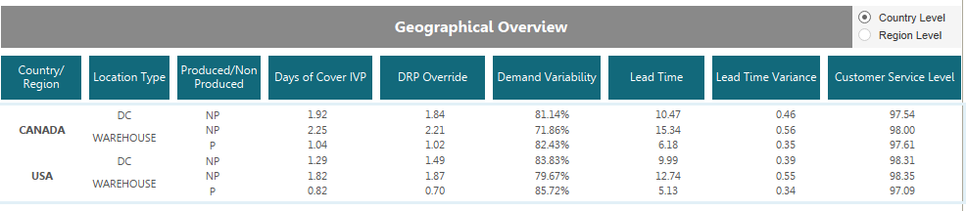

**Click here to toggle between Country and Regional Summary.**

### 

### 2.1.3 Geographic Overview

This filled map gives us a regional level overview of the selected metric in the DRP/IVP toggle. The colour varies from green to red corresponding to the value of the above selected metric. Hovering over a region would display the actual DRP/IVP DoC value. Selecting a particular region in the map would take us to the location level map which consists of location summary of the selected region. In addition to this, the selection would also affect the Country/Regional summary.

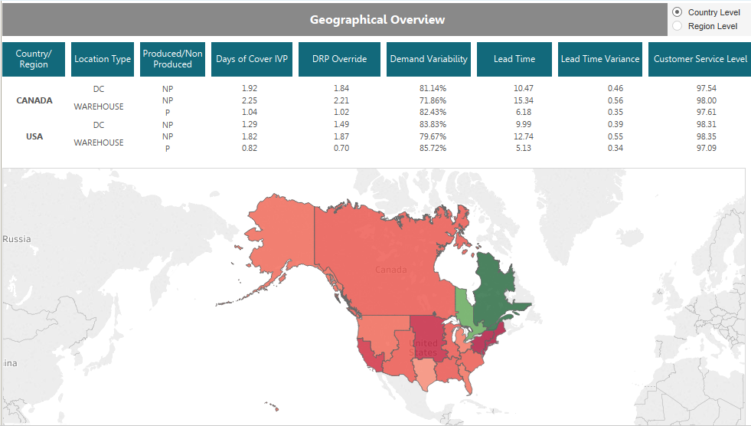

### 2.1.4 Location Overview

This view gives us a summary of all the locations in the selected region. The colour varies based on the value of the metric selected above (DRP/IVP). Hovering over the location on the map will highlight that particular location in the location week-over-week summary following the map whereas clicking the location would take us to the location deep dive dashboard.

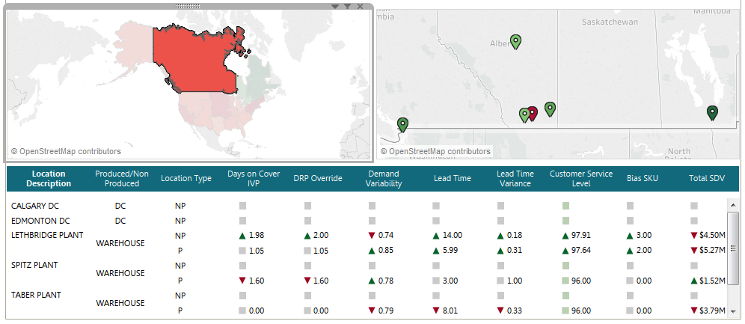

### 2.1.5 Location Summary for a Region

This table gives us the current week performance, of all locations in the selected region, compared to the previous week. The arrows denote either an increase, decrease or no change in the corresponding metric value.

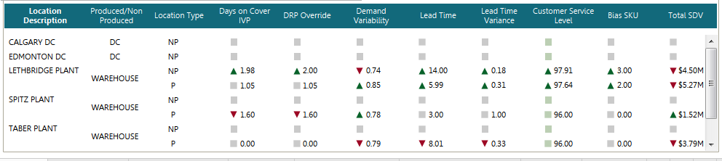

## 2.2 Location Deep-dive

### 2.2.1 Universal Controls/ Filters

This section outlines the overall controls and filters common across all dashboards.

#### 2.2.1.1 Filters Panel

The filter panel contains all the global filters that can be applied on all the dashboards



#### 2.2.1.1.1 Location

The Location Filter is used to select a particular location for which the data can be viewed.

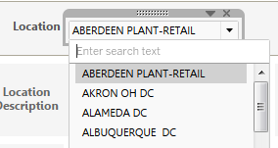

**Click here and select the corresponding Location for which you want to view the data.**

#### 2.2.1.1.2 Year

The Year filter provides an option to select the year to view the data for the same.

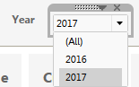

**Click here to select a year**

#### 2.2.1.1.3 Period Week Filter

The period here is divided into 13 periods according to the PepsiCo System, with each period having 4 weeks and the user can select one of the period-week combination for the selected year to view the data.

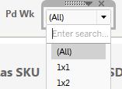

**Click here and select the corresponding period-week for which you want to view the data.**

#### 2.2.1.2 Navigation

This section deals with Navigation present within the Location Deep-dive section of the Safety Stock Location Level Dashboard.

#### 2.2.1.2.1 Metric to Metric Navigation

Location Deep-dive section has 7 Dashboards, each representing a particular metric. The Navigation pane is present on the top of each dashboard. The Darker tab indicates the metric in view below. The lighter tabs represent the other metrics available that you can navigate to by clicking on them.

**This navigation pane is present in the Location Deep-dive section of the Safety Stock Location Level Dashboard. The darker tab highlights the current metric in view**



**Click on any of the lighter tabs to navigate to a particular metric**

#### 2.2.1.2.2 Home Navigation

This Navigation takes you back to the Landing Page.



**Click here to go to the Landing page.**

#### 2.2.1.2.3 SKU Dashboard Navigation

This Navigation takes you to the Safety Stock SKU Level Dashboard.



**Click here to go to the SKU Level Dashboard.**

#### 2.2.1.3 Week toggle for the Graph

This toggle enables to select the number of weeks on the x-axis to be displayed on the graph. The trends can be viewed for the first 26 weeks of the year, last 26 weeks or the entire 52 weeks present in the year.

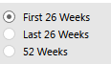

**Click here to toggle between different views based on which weeks are represented in the trends.**

#### 2.2.1.4 Location Level Metric Table

This table gives us the location level summary of each of the metric. The header for the columns is also used to navigate to different metric trends as explained above.

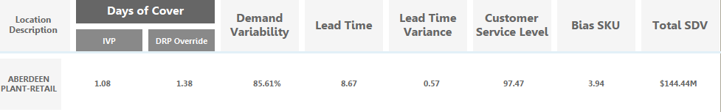

### 

### 2.2.2 Metric level Dashboards

#### 2.2.2.1 Days of Cover

This Dashboard shows the trends for Days of Cover IVP and Days of Cover DRP.

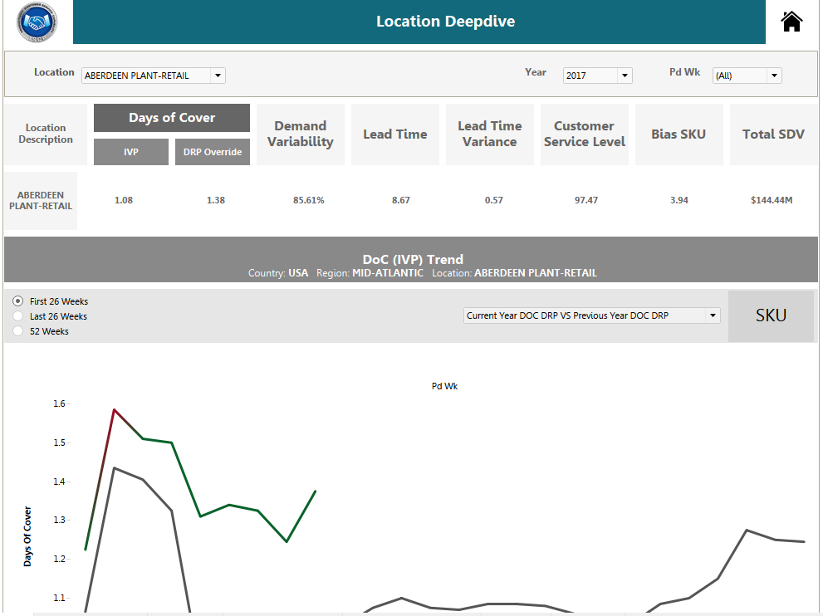

We can navigate between four graphs using the Dropdown present next to the SKU Navigation.

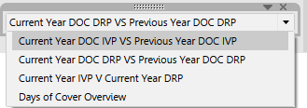

**Click to select a graph.**

The Legend below the Trend changes dynamically depending on which graph has been selected.

For the graphs Current Year DOC DRP VS Previous Year DOC DRP, Current Year DOC IVP VS Previous Year DOC IVP and Current Year IVP VS Current Year DRP, the trend line changes from green to red when the value of the metric that you are comparing changes by a factor of 0.2.

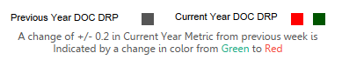

When the Days of Cover Overview Graph is selected, different colours are used to look at different metrics. Days of Cover Overview graph does not show any colour change based on the value of metric, which was seen in the other three graphs. The graph is meant to give an overview of Days of IVP and DRP for both the current year and the previous year.

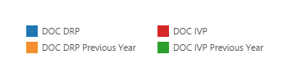

#### 2.2.2.2 Demand Variability

This Dashboard shows the trends for Demand Variability

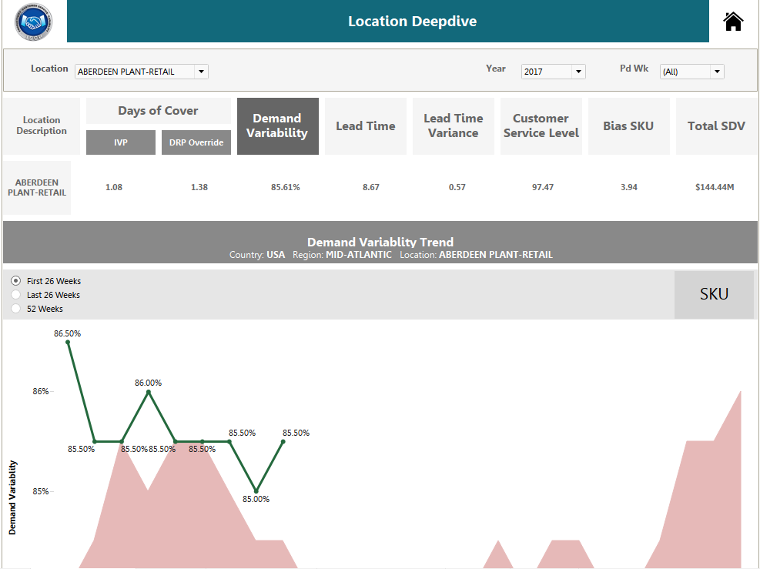

The Current Year Demand Variability is represented by a line graph while the previous year Demand Variability is represented by an Area chart.

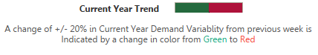 

The current year Demand Variability trend line changes from green to red when the value of the metric that you are comparing changes by a factor of 20%.

#### 2.2.2.3 Lead Time

This Dashboard shows the trends for Lead Time

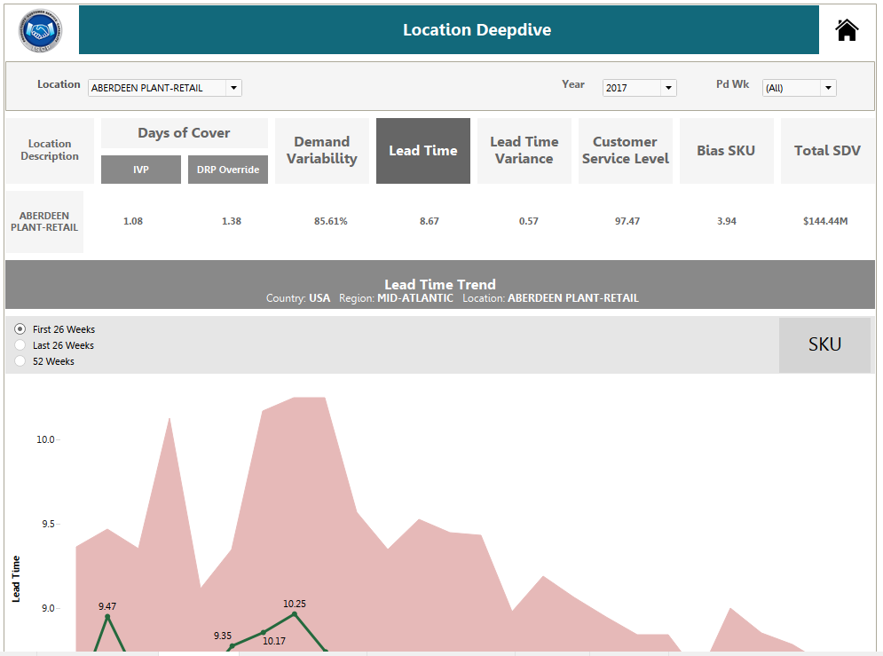

The Current Year Lead Time is represented by a line graph while the previous year Lead Time is represented by an Area chart.

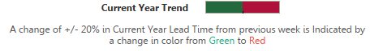 

The current year Lead Time trend line changes from green to red when the value of the metric that you are comparing changes by a factor of 20%.

#### 2.2.2.4 Lead Time Variance

This Dashboard shows the trends for Lead Time Variance

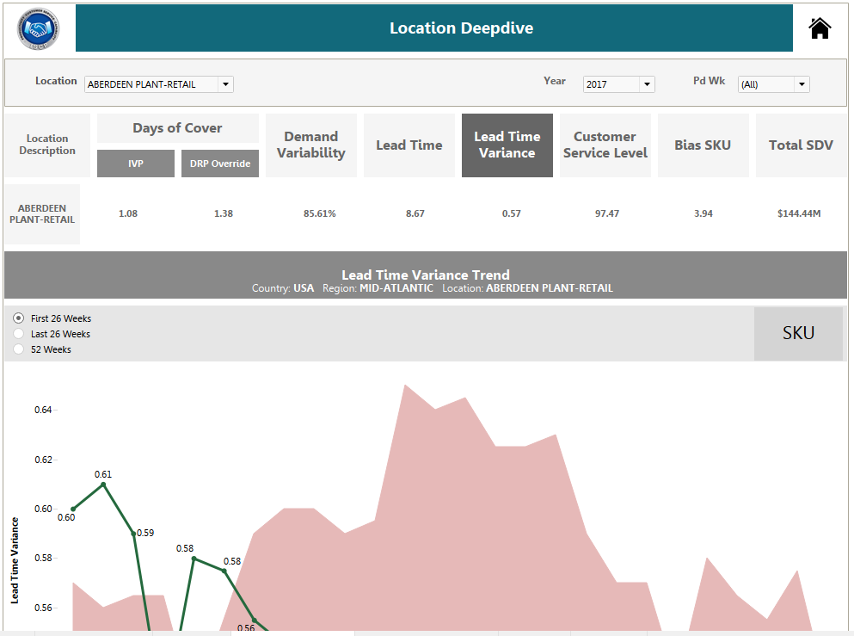

The Current Year Lead Time Variance is represented by a line graph while the previous year Lead Time Variance represented by an Area chart.

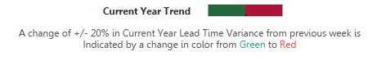 

The current year Lead Time Variance trend line changes from green to red when the value of the metric that you are comparing changes by a factor of 20%.

#### 2.2.2.5 Customer Service Level

This Dashboard shows the trends for Customer Service Level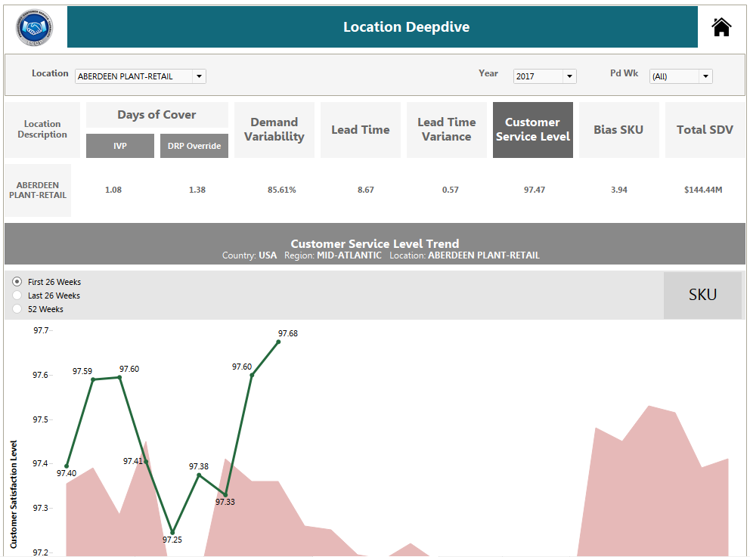

The Current Year Customer Service Level is represented by a line graph while the previous year Customer Service Level is represented by an Area chart.

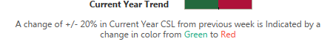 

The current year Customer Service Level trend line changes from green to red when the value of the metric that you are comparing changes by a factor of 20%.

#### 2.2.2.6 Bias SKU

This Dashboard shows the trends for Bias SKU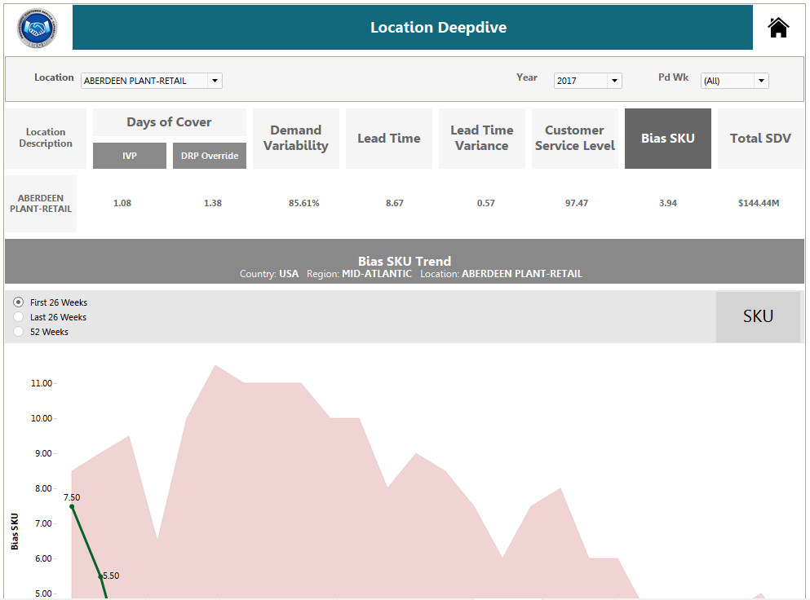

The Current Year Bias SKU is represented by a line graph while the previous year Bias SKU is represented by an Area chart.

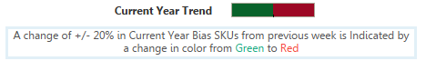 

The current year Bias SKU trend line changes from green to red when the value of the metric that you are comparing changes by a factor of 20%.

#### 2.2.2.7 Total SDV

This Dashboard shows the trends for Total SDV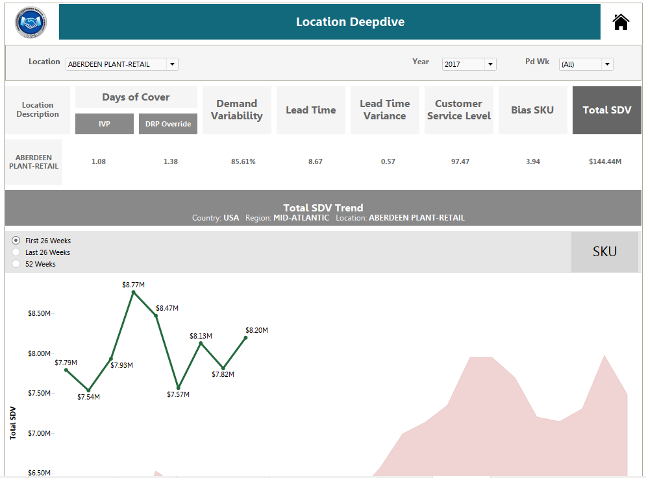

The Current Year Total SDV is represented by a line graph while the previous year Total SDV is represented by an Area chart.

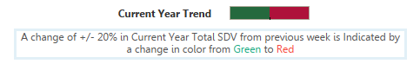 

The current year Total SDV trend line changes from green to red when the value of the metric that you are comparing changes by a factor of 20%.

# 3 Safety Stock - SKU Level Dashboard

The Safety Stock - SKU Level Dashboard provides an overview of the metrics of all the SKU’s in a Location.

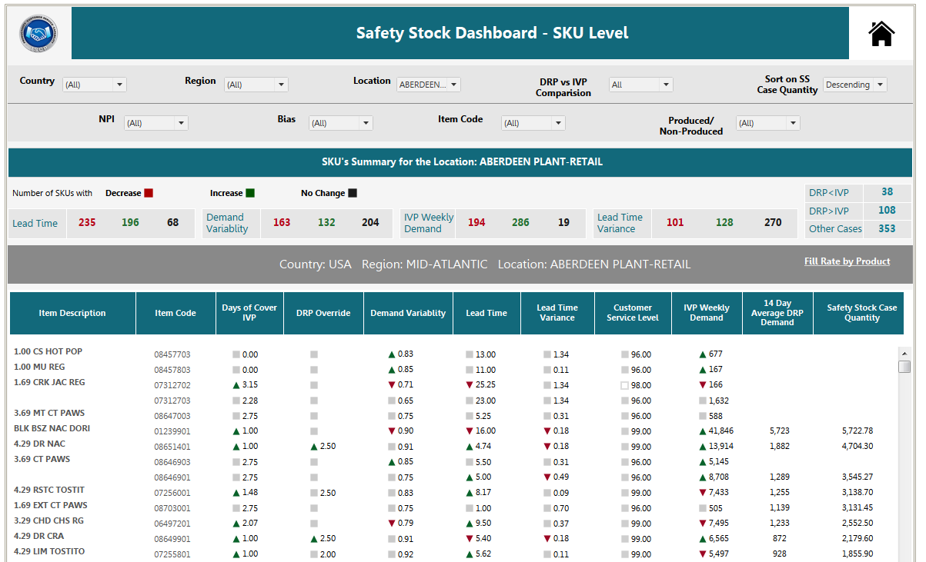

## 3.1 Global Filters and Navigation

### 3.1.1 Home Navigation

This Navigation takes you back to the Landing Page.



**Click here to go to the Landing page of the Safety Stock - Location Level dashboard.**

### 3.1.2 Fill Rate by Product Navigation

This Navigation takes you to the Fill Rate by Product Dashboard.



**Click here to go to the Fill Rate by product Dashboard.**

### 3.1.3 Filters



#### 3.1.3.1 Country

The Country filter provides an option to select the Country to view the data for the same.

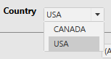

**Click here to select a Country**

Note:

To select a different Country - Region and Location filters must be made to show all values.



**Set Region and Location Filter Values to “All” before changing the Country**

#### 3.1.3.2 Region

The Region filter provides an option to select the Region to view the data for the same.

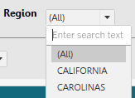

**Click here to select a Region**

Note:

To Select a different Region - Location filter must be made to show All Values.

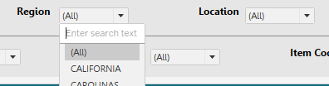

**Set Location Filter Values to “All” before changing the Region**

#### 3.1.3.3 Location

The Location filter provides an option to select the Location to view the data for the same.

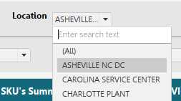

**Click here to select a Location**

#### 3.1.3.4 DRP IVP Comparison

The DRP IVP Comparison filter provides an option to select a particular set of SKU’s based on DRP IVP comparison and view the data for the same.

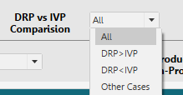

**Click here to select a particular set of SKUs**

#### 3.1.3.5 Sort

The Sort filter helps you sort the data based on Safety Stock Case Quantity.

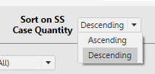

**Click here to select a particular Sort Option**

#### 3.1.3.6 NPI

The NPI filter helps you filter SKUs based on option selected

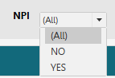

**Click here to select**

#### 3.1.3.7 Bias

The Bias filter helps you filter SKUs based on option selected

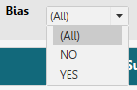

**Click here to select**

#### 3.1.3.8 Item Code

The Item Code filter helps you filter SKUs based on option selected.

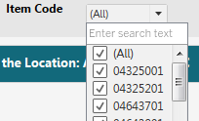

**The item code can be typed-in and then the box should be ticked.**

#### 3.1.3.9 Produced/Non Produced

The Produced/Non Produced filter helps you filter SKUs based on option selected

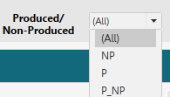

**Click here to select**

**NOTE: For Users Pausing the Dashboard**



There are 9 filters in total, demarcated into two groups by a line.

The Filters above the line, namely Country, Region, Location, DRP Vs IVP Comparison, and Sort on SS Case Quantity must be fixed before pausing the Dashboard.



After setting the values of the filters above, we can pause the Dashboard and Set the values of the filters below the line namely, NPI Bias, Item Code, Produced/ Non Produced.



After the filter values are set, you may resume the Dashboard one again.

## 3.2 Summary Points

The summary points in the Safety Stock SKU Level consists of details on the Number of SKU with a decrease in the value of a metric compared to the previous week. This summary is available for Lead Time, Demand Variability, IVP Weekly Demand and Lead Time Variance. In addition, the summary provides the number of SKU’s with DRP<IVP, DRP>IVP and Other Cases. The Other Case values include values for which comparison could not be made (either DRP or IVP values are missing or Null) and values for which DRP and IVP values were equal.

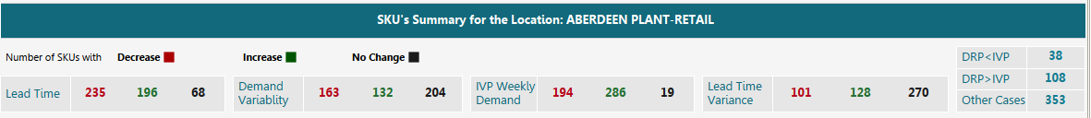

## 3.3 Week on Week Comparison Table

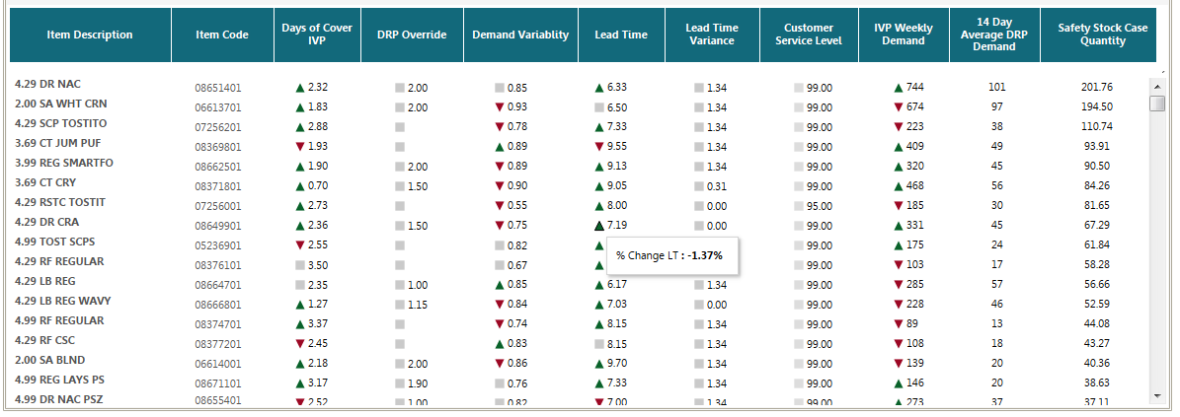

The Week on Week Comparison Table gives the values of the metrics for the current week. The table includes the metrics, Days of Cover IVP, DRP Override, Demand Variability, Lead Time, Lead Time Variance, Customer Service Level, IVP Weekly Demand, 14 Day Average DRP Demand and Safety Stock Case Quantity. The arrows denote either an increase (Up Arrow-Red), decrease (Down Arrow-Green) or No Change (Grey Squares). If we hover over any of the metrics we can see the percentage change with respect to last week.

For the Column Days of Cover IVP, the factor of change is indicated on hover instead of the percentage of change.